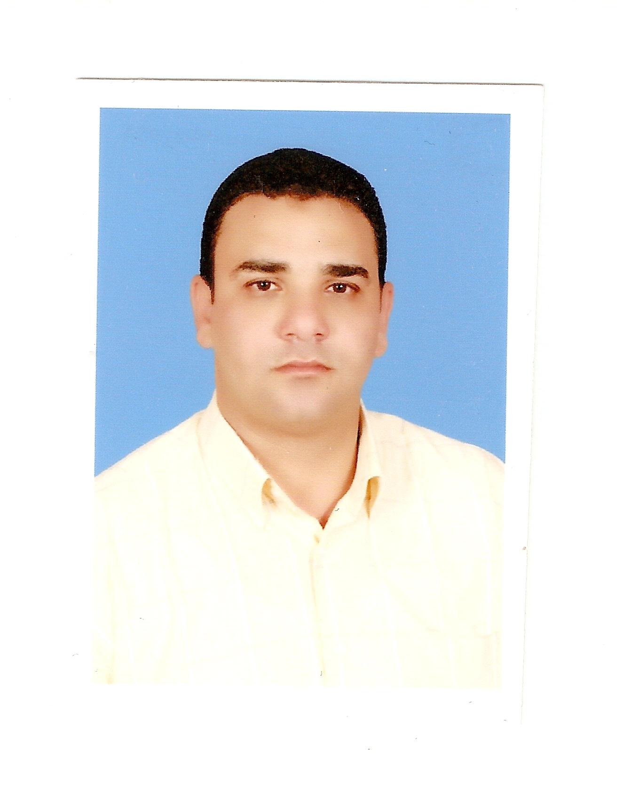
CURRICULUM VITAE
Ali Mahfouz Morsi Ali Elgendi

Personal data :

Name : Ali Mahfouz Morsi Ali Elgendi
Qualification : Bachelor's degreeMathematics and Computer Science Division
Master of Science in Mathematics

The job : Researcher for educational affairs, Minia University

Sex : Male
Marital status : Married +3
Date of birth March, 1-3-1970
Place of birth : EL Minia -Bander Mallawi
Current address : Minia University - Faculty of Education
Mobil number : 002-01092892730 01002659676 و
E-mails : ali_elgendi@sci.svu.edu.eg
.

